Mr Twitt is missing!
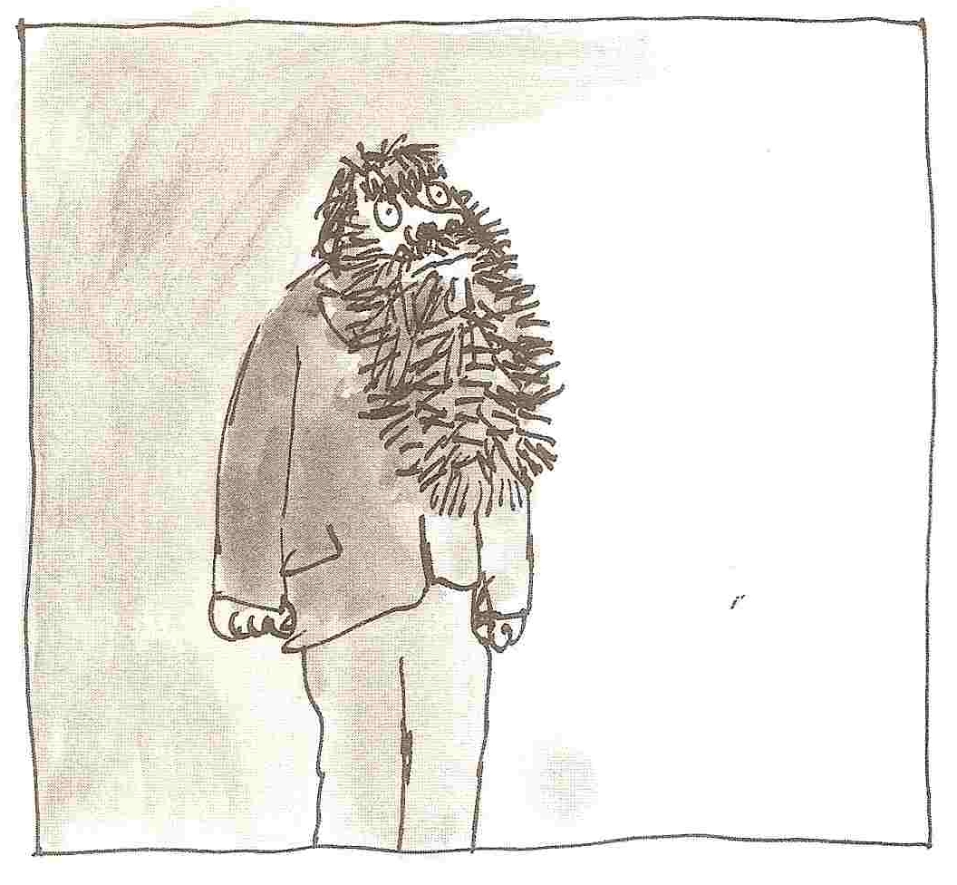
Which of these adjectives describe Mr Twitt?
pretty hairy scruffy clean dirty smelly untidy smart old young smudgy tidy bristly bushy ugly

Describe Mr Twitt’s appearance. What does he look like?
Mr Twitt is a _________ -faced man. He has a big __________ beard that sticks straight out of his chin. His face is _____________ and ____________ because he doesn’t wash, not even on a Sunday. His clothes are __________. This hair sprouts out of his ________________________________________ . When he eats __________________________________________________ .
Around his mouth you can see______________________________________.
Describe Mr Twitt’s personality. What is he like as a person?
foul | Mr Twitt is foul old man who is nasty to his wife .
mean | Mr Twitt is a old man who is to
nasty | Mr Twitt is a
cruel
horrid

